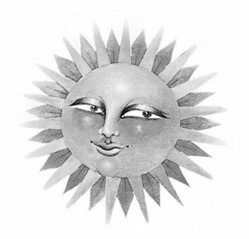
$500 Kirby Music Scholarship
2026 Application Form
______________________________________________________________________INSTRUCTIONS: To apply for the Kirby Scholarship, please do the following:
• Complete this application form.
• Write a brief description of your musical interest.
This application must be received at the following address by MARCH 20, 2026
The Columbus Folk Music Society c/o Linda McDonald
444 Oakland Park Ave
Columbus, Ohio 43214
The award winner will be notified by APRIL 8, 2026.
==================================================================
NAME_________________________________________________AGE____________
School_______________________________________________GRADE__________
HOME ADDRESS_____________________________________________________________
______________________________________________________________________
PHONE NUMBER_______________________________________________________
Parent E-MAIL ADDRESS: ______________________________________________________________________
SIGNATURE of Parent / Caregiver______________________________________________________________

KIRBY MUSIC SCHOLARSHIP
$500 AWARD
Americana folk music represents a significant part of our country’s heritage. It is our goal to perpetuate interest in this music. The recipient of this award will have an opportunity to learn about the folk music tradition, make music of his or her own, and have fun with people who like to do the same.
Bob Kirby supported music in central Ohio and believed in the importance of preserving musical traditions. In harmony with our mission, The Columbus Folk Music Society established The Bob Kirby Scholarship for Music in his memory.
PURPOSE
To assist young musicians from the central Ohio area by offering new musical opportunities
● To enhance musical skills
● To pursue a greater knowledge of, and appreciation for folk music
● To offer performance experience
REQUIREMENTS
● Open to All Students in grades 3-12
● Submit a letter explaining your interest in music, your musical goals, what musical instrument you are interested in playing (or play) and if you sing.
● An interview will be held with the top 5 applicants
BENEFITS
● Free household admission to The Central Ohio Folk Festival 2026, June 6 & 7 at Bank Run Metro Park
● $40 for meals at the festival
● An opportunity to perform at The Central Ohio Folk Festival 2026 (not required)
● $500.00 award to be used toward music, such as, but not limited to, instrument purchase or music lessons
● The CFMS newsletter “A Different Strummer” will be sent monthly to the winner.
Disclaimer: This award and the criteria are subject to change at the discretion of the Scholarship
Committee. For additional information email:lindamcdonald@columbusfolkmusicsociety.org

